Chapter 4 Electric fields
Chapter Test Total marks 41

Name: __________________________ Class: ______ Date: ______
A data sheet with appropriate physics constants will be provided for this test.
Question 1
A Van de Graaff generator creates an electric charge on the surface of its aluminium dome due to the friction of a rubber belt rotating inside the dome. When small pieces of cottonwool are gently tossed towards a charged Van de Graaff generator, the cottonwool pieces are attracted to the dome. After being in contact with the dome for a short time the cottonwool pieces are repelled from the dome. Explain these observations using the appropriate physics concepts. (3 marks)

Question 2
- Complete the diagram below by giving the charges that would result in the field lines shown. (1 mark)
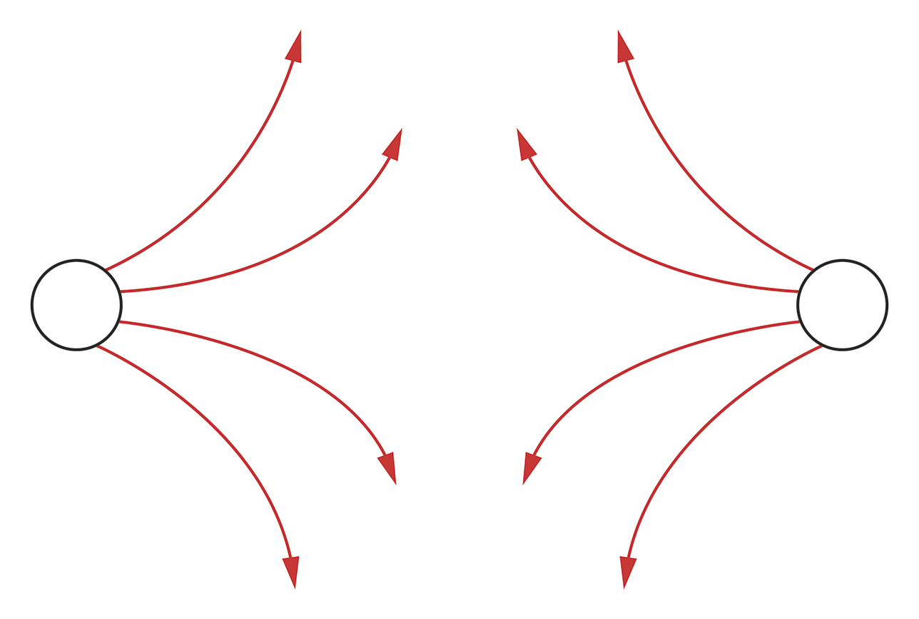
- Complete the diagram below by drawing the field lines coming from the charged objects. Draw lines going all around the circular object and at least 5 lines coming up from the plate. (3 marks)

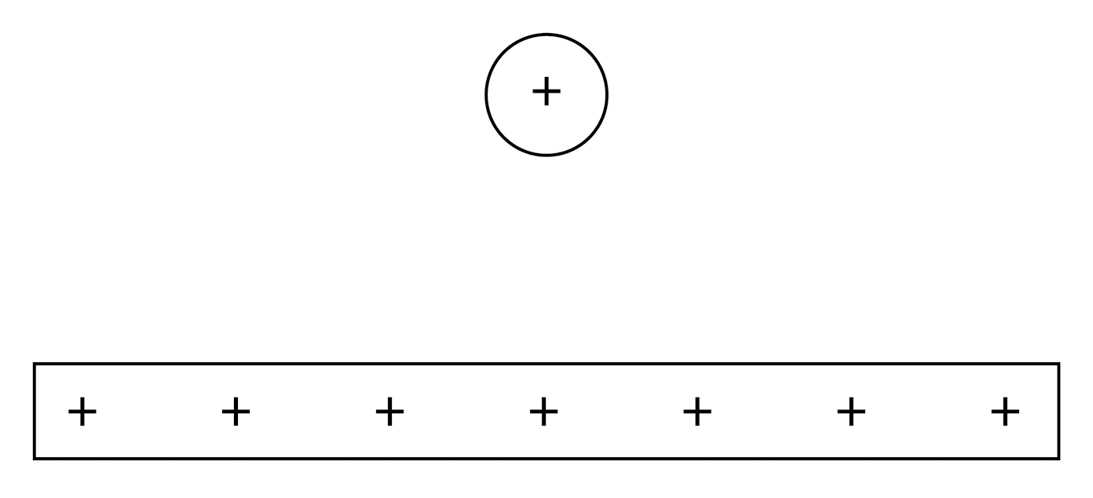

Question 3
A charged Styrofoam ball of mass 0.32 g is suspended 2.0 cm above a plate carrying a charge of −4.72 × 10⁻⁷ C.
- Is the charge on the styrofoam ball positive or negative? (1 mark)

- What is the magnitude of the charge on the ball? (4 marks)

- The ball has developed the negative charge by accumulating electrons on its surface. How many electrons does it need to accumulate to gain the charge calculated in (b)? (2 marks)

Question 4
Calculate the net force on particle 3 in the diagram below. The charge on particle 1 is −4.8 × 10⁻⁶ C, particle 2 +3.2 × 10^{–6} C, and particle 3 +3.0 × 10^{–6} C. (6 marks)

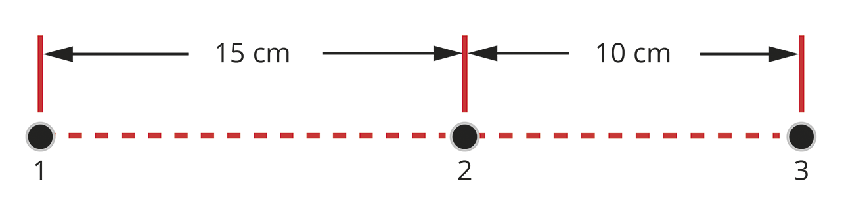

Question 5
A researcher carried out an experiment to determine the electrical permittivity for a polymer. She separates two point charges by a 2.00 mm piece of the polymer and measures the force between them. One charge is kept constant at 5.00 × 10⁻⁸ C while the other charge is varied over the course of the experiment. After obtaining her measurements, she plots a graph of the charge on the varied point charge against the force measured between the two charges. The graph below is a plot of the measurements.

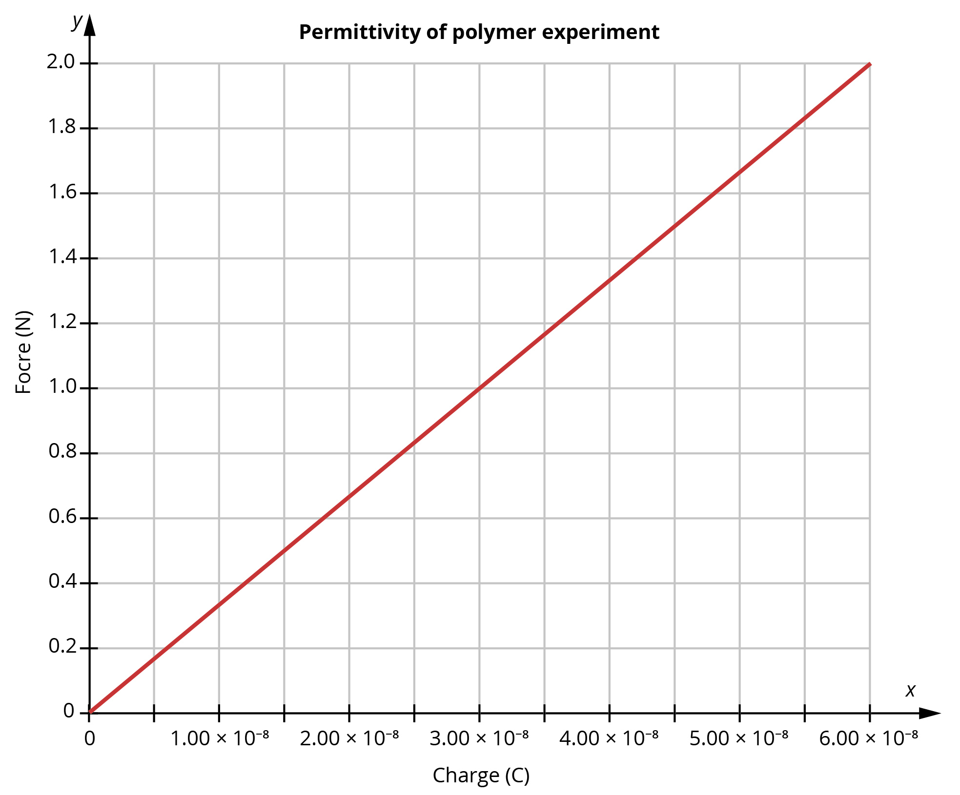
Determine the gradient of the line and use this to find the permittivity of the polymer.
(6 marks)

Question 6
Sodium and chloride ions are held in place in solid sodium chloride by the electrostatic attraction between the oppositely charged ions as represented in the diagram below.

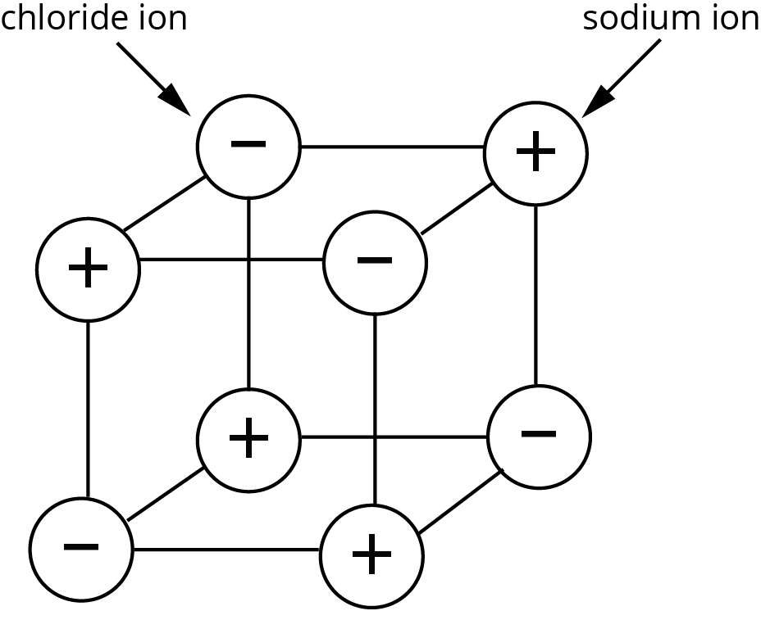
Sodium chloride has a high melting point due to the strength of the electrostatic attractions between the sodium and chloride ions but it will dissolve readily in water. Suggest what this observation indicates about the strength of the electrostatic attractions between sodium and chloride ions in water and give a reason for this based on the appropriate physics principles. (2 marks)

Question 7
Calculate the strength and direction of the electric field at point A 28 cm from point B which has a charge q = −6.5 × 10⁻⁵ C as indicated in the diagram below. (5 marks)

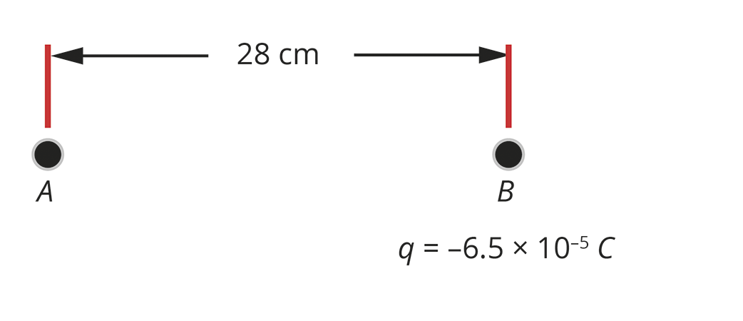

Question 8
X-rays can be generated by firing high-speed electrons from a cathode onto an anodic metal plate. When the electrons strike the metal plate, some of their energy is converted to X-rays. If there is a 65 kV potential difference between the cathode and the metal plate in an X-ray tube, how much work does an electron do when it travels from the cathode to the anode? (3 marks)

Question 9
- A positively charged plate is 5.00 cm above a negatively charged plate, and the electric field strength between the plates is 3.45 × 10² N C⁻¹. How much work is done by the electric field to move a proton from the negative to the positive plate?
(3 marks)

- An electron travels 3.50 mm in a circular arc around a point positive charge that generates an electric field of 7000 N C⁻¹. The electron’s path is represented below. What work is done by the electron in moving along this arc? Explain your answer.
(2 marks)

